NAME : WIJAYAWARDHANA W.A.H.A.

REGISTRATION NO. : 2019/E/166

SEMESTER : SEMESTER 04

DATE ASSIGNED : 24 MARCH 2022

TREE – LAB 06

EC 4070

DATA STRUCTURES AND ALGORITHMS

01.

**Code:-**

public class CityDatabase {

double[][] cityDetails = new double[20][3];

String[][] cityNameArray = new String[20][2];

int arraySize = 3;

double longitude;

double latitude;

String cityName;

int root;

int idNumber = 1;

/**

* setCityDataDetails method use for set city details to the 2D array.

* @param cityName

* @param latitude

* @param longitude

* @param index

*/

public void setCityDataDetails(String cityName , double latitude , double longitude , int index)

{

if(root == 0)

{

cityDetails[1][0] = idNumber;

cityDetails[1][1] = latitude;

cityDetails[1][2] = longitude;

cityNameArray[1][0] = String.valueOf(idNumber);

cityNameArray[1][1] = cityName;

idNumber++;

System.out.println(cityName + " added.");

}

else

{

this.cityName = cityName;

this.latitude = latitude;

this.longitude = longitude;

cityDetails[index][0] = idNumber;

cityDetails[index][1] = latitude;

cityDetails[index][2] = longitude;

cityNameArray[index][0] = String.valueOf(idNumber);

cityNameArray[index][1] = cityName;

idNumber++;

}

}

/**

* Insertion method use for add elements into the tree.

* @param cityName

* @param latitude

* @param longitude

*/

public void insertion(String cityName , double latitude , double longitude)

{

this.cityName = cityName;

this.latitude = latitude;

this.longitude = longitude;

root = 1;

findArrayIndex(root);

}

/**

* This alphabeticalOrder method use to set city names in alphabetical order.

* @param city01

* @param city02

* @return

*/

public boolean alphabeticalOrder(String city01 , String city02)

{

return city01.compareTo(city02)>0;

}

/**

* This method use to find the array index.

* @param i

*/

public void findArrayIndex(int i)

{

boolean city02High = alphabeticalOrder(cityNameArray[i][1],cityName);

if(city02High == true)

{

if(cityNameArray[2*root][1] == null)

{

cityNameArray[2*root][0] = String.valueOf(2*root);

cityNameArray[2*root][1] = cityName;

System.out.println(cityName + " added.");

setCityDataDetails(cityName,longitude,latitude,2*root);

return;

}

else

{

findArrayIndex((2*root));

}

}

else

{

if(cityNameArray[2*root+1][1] == null)

{

cityNameArray[2*root+1][0] = String.valueOf(2*(root+1));

cityNameArray[2*root+1][1] = cityName;

System.out.println(cityName + " added.");

setCityDataDetails(cityName,longitude,latitude,2*root+1);

return;

}

else

{

findArrayIndex((2*root+1));

}

}

}

/**

* printDetails method use to print the details of the array.

*/

public void printDetails()

{

System.out.println("Print details.");

for (int i = 1; i < arraySize; i++)

{

for (int j = i + 1; j < arraySize; j++)

{

if(cityNameArray[i][1].compareTo(cityNameArray[j][1]) > 0)

{

String temp = cityNameArray[i][1];

String temp2 = cityNameArray[i][0];

cityNameArray[i][1] = cityNameArray[j][1];

cityNameArray[i][0] = cityNameArray[j][0];

cityNameArray[j][1] = temp;

cityNameArray[j][0] = temp2;

}

}

}

for(int i =0; i<cityNameArray.length;i++)

{

if(cityNameArray[i][1] != null)

System.out.println(cityNameArray[i][1]);

}

}

/**

* descendingOrderPrint method use to print tree in descending order.

*/

public void descendingOrderPrint()

{

for(int i = cityNameArray.length-1; i>=0;i--)

{

if(cityNameArray[i][1] != null)

System.out.println(cityNameArray[i][1]);

}

}

/**

* deleteItem method use to delete element from the tree.

* @param cityNameToDelete

*/

public void deleteItem(String cityNameToDelete)

{

int i =0;

for(; i<arraySize; i++)

{

if(cityNameArray[i][1] == cityNameToDelete)

{

System.out.println(cityNameArray[i][1] + " deleted.");

cityNameArray[i][0] = null;

cityNameArray[i][1] = null;

arraySize--;

}

}

}

/**

* searchCityName method use to search the element using name of the city.

* @param searchCityName

*/

public void searchName(String searchCityName)

{

boolean isFound = false;

for(int i =0; i<arraySize; i++)

{

if(cityNameArray[i][1] == searchCityName)

{

System.out.println(searchCityName+ " founded.");

isFound = true;

}

}

if(isFound == false)

{

System.out.println(searchCityName+ " do not found.");

}

}

/**

* calculateDistance method use to get the distance less than the given value.

* @param distance01

*/

public void calculateDistance(double distance01)

{

for(int i = 0; i<cityDetails.length; i++)

{

if((cityDetails[i][1] < distance01)&&((cityDetails[i][1] >0)||(cityDetails[i][1] <0)))

{

System.out.println("City less than "+distance01+ " : "+cityNameArray[i][1]);

}

}

}

/**

* main method to run the written methods.

* @param args

*/

public static void main(String[] args) {

CityDatabase newObject = new CityDatabase();

newObject.setCityDataDetails("Colombo",6.927079,79.861244,0);

newObject.insertion("Chicago",41.881832,-87.623177);

newObject.insertion("Sydney" , -33.865143 ,151.20990);

newObject.calculateDistance(72.495865);

newObject.printDetails();

newObject.deleteItem("Colombo");

newObject.printDetails();

newObject.searchName("Chicago");

newObject.searchName("Kandy");

System.out.println("Descending order : ");

newObject.descendingOrderPrint();

newObject.printDetails();

}

}

**Output:**

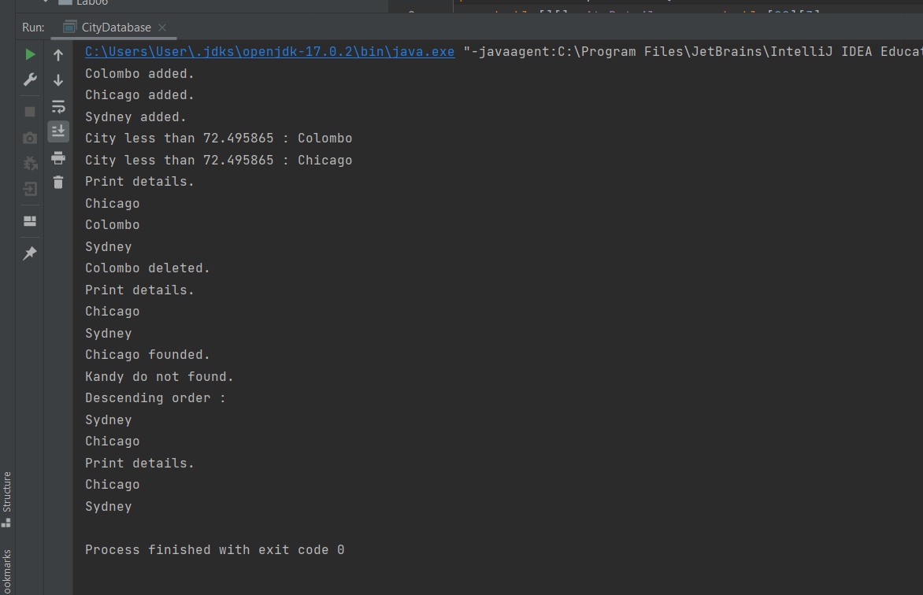

FIGURE 01 - OUTPUT